Integrated

Analysis

This course describes issues and logs in Cortex®, and how Cortex correlates these security-related datasets for causality analysis. The course also describes the Cortex Analytics Engine.

Course Objectives
After completing this course, you should be able to:

- Describe how the security-related data types are sent to Cortex
- Describe how Cortex stitches the logs and issues
- Describe how the Analytics Engine models the data using machine learning (ML)
- Describe MITRE ATT&CK tactics and how the Analytics Engine provides full coverage
- Explain how Analytics Engine detectors identify suspicious behavior and generate issues

Lesson Topics
We recommend that you take the lessons in numerical order, but you can use the menu for quick access to any lesson at any time.
Click the lesson title buttons to go to each lesson. You can also navigate the course using the navigation arrows below or the menu bar at the top left of the screen.
Lesson 1: Log Stitching
Lesson 2: Analytics Engine

Log

Stitching

This lesson describes how Cortex collects and correlates issues and logs to derive event causality and timelines.

Issues and Logs
When data is sent to a Cortex instance, it comes in two types: issues and logs. Each type serves a specific purpose and provides different insights into potential security threats.

Issues
Issues are instantly created to capture details of suspicious activities and are immediately uploaded to a Cortex instance. However, due to their quick creation and processing, issues may not capture all activity details, such as process-resource interactions, making them insufficient for behavioral threat analysis on their own.
The Issues table in the management console displays a minimum set of attributes, such as a timestamp, severity, and issue name.

Logs
Logs can be any type of data, not necessarily attack-related information, and are periodically uploaded to the Cortex instance. Unless associated with issues, logs alone may not provide enough information for behavior analysis. Examples of log types include enhanced endpoint data, firewall traffic logs, and authentication logs.
As a wide variety of log types can be sent to Cortex, the management console may not provide a dedicated table for logs. However, it does offer tables for viewing audit logs, including Management Audit, Agent Audit, and XDR Collector Audit within the Settings menu. For the remaining logs, users can access them using Cortex Query Language (XQL) search queries or create Cortex Correlation rules based on the logs.

Issues Correlated with Logs
Cortex can correlate issues and logs, which is also known as log-stitching. This merging process results in enhanced issues with more attributes (fields) containing information about the attack details.
The analysis of a stitched issue can reveal:

Causality Chains
Cortex can regenerate causality information that displays the attack-related process-resource interactions in hierarchical causal graphs.

Timelines
Cortex can display the timeline of when those attack-related process executions were invoked.

Enhanced Endpoint Data Collection
The Cortex XDR Pro Endpoints agents, also known as Pro Agents, can collect enhanced endpoint data (EED) logs on endpoints. The XDR agent also performs these ongoing tasks, including operating system (OS) monitoring, data sampling, collecting (saving locally), compressing, and uploading. The collected logs are uploaded every five minutes to the Cortex instance that the agent is connected to. To directly access the collected data, you can build search queries using the management console's Query Builder or leverage XQL.

What Data Is Collected?
Enhanced endpoint data includes several log types.

Process Operations
These logs capture events related to operating system resources such as files, processes, networks, and registry activities. Examples include file read and write operations and child process creations.

Network Operations
These logs capture endpoint events related to network activity, such as accept, connect, and listen events. Examples include failed connections or the source and destination IP address and port.

Enable EED Collection
The EED collection capability can be enabled or disabled in the XDR Pro Endpoints section of a Agents Settings profile.
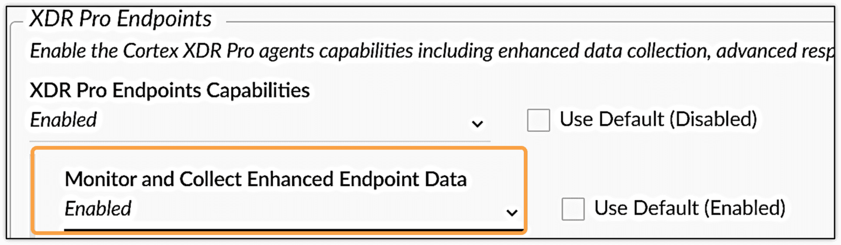

Extended Threat Hunting Data
By default, agents with a Cortex XDR Pro per Endpoint license apply limits to network, file, and registry logs. The Extended Threat Hunting (XTH) add-on is required to expand these capabilities. The add-on enables the collection of RPC calls, system calls, and event logs on Windows, and it enables file activity and event logs on Mac and Linux.

Stitched Issues in the Issues Table
You can identify stitched issues in the Issues table by checking attributes related to causality, such as Causality Group Owner (CGO) Name, CGO Signer, and Causality ID (CID), which shows the stitching status.
Most causality-related attribute names begin with the CGO prefix. Any non-blank causality-related attribute indicates that the issue has been stitched.
Note: The green dot in the first column does not indicate the stitching status of an issue. It signifies that the issue is eligible for analysis in the Causality View.
Click the image to enlarge it.
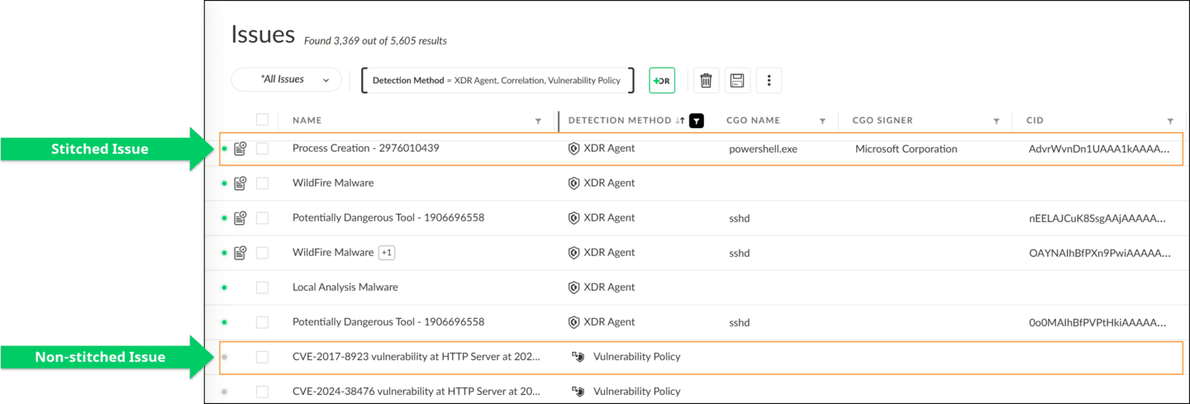

Stitched Issue Actions
A stitched issue provides advanced investigation and visualization actions: Open Card and Open Timeline.

Open Card
Open Card displays the entire process execution chain that triggered the issue in the Causality View.

Open Timeline
Open Timeline displays stages of the attack lifecycle and all the issues, including informational-severity issues in the Timeline View.
Click the image to enlarge it.
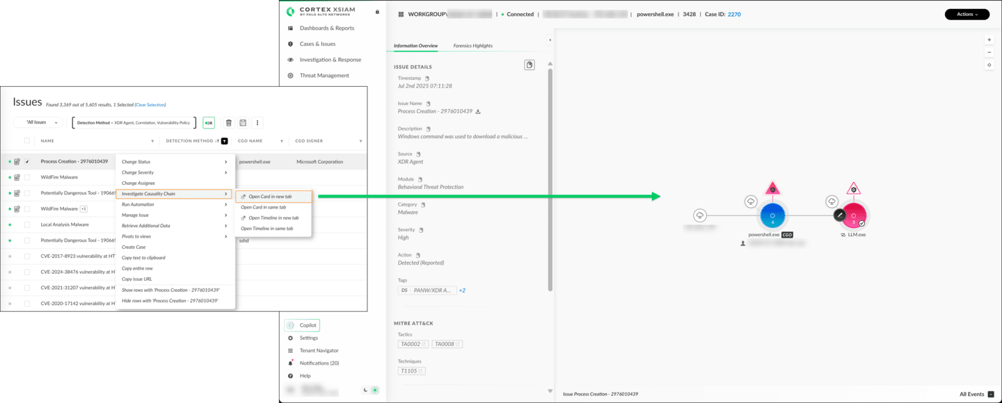

Open Card Action and Non-Stitched Alerts
Open Card action is still available for non-stitched issues generated by the XDR agent, but the analysis is limited. For example, you cannot view all the processes involved in the attack. This case occurs when you disable enhanced endpoint data uploads on a Cortex instance with the Pro per Endpoint license. For other non-stitched issues that are created by external applications, all of these actions are disabled.

Checking Stitching Status
You can check the log collection and log stitching status by reviewing the issue attributes displayed in the JavaScript Object Notation (JSON) format.
To view the JSON attributes of an issue, Alt + right-click (Windows) or Opt + right-click (Mac) on an issue to open the actions menu, and then click Debug issue. Make sure to check the following attributes:
- 
- matching_status
- This is the correlation status of this issue with enhanced endpoint data.
- 
- agent_data_collection_status
- This indicates whether the enhanced endpoint data upload was enabled when this issue was created on the endpoint.

Analytics

Engine

This lesson provides an overview of how the Cortex Analytics Engine uses behavioral analytics to detect and respond to attack statics defined by MITRE ATT&CK.

Behavioral Analytics
The CAE detects and responds to hidden, post-intrusion threats that have evaded network defenses before the attacks ruin the systems.
The process of how the Analytics Engine detects anomalies using behavior analytics is as follows:

1. Learning Normal Behavior
The Analytics Engine first uses machine-learning-based analytics to learn the normal behavior of entities such as users, endpoints, and networks.
Normal behavior of the entities also is known as baselines. To set the baselines, the engine employs unsupervised machine-learning techniques in which no in-advance labeling is required.
Note: The setting of baselines is a learning process that is also known as profiling.

2. Comparing Activities to Normal Behavior
After learning the normal behavior of entities, the engine compares ongoing activities with the normal behavior and raises issues when suspicious activity is detected.
For example, the engine can detect unexpected changes in connectivity patterns, including increased rates of connections, failed connections, and port scans.

MITRE ATT&CK Tactics
The Analytics Engine can raise an issue for any of the following attack tactics as defined by the MITRE ATT&CK tactics.
Some MITRE ATT&CK tactics are described as follows:

Execution tactics include various techniques to execute malicious code on a local or remote endpoint after gaining access to the network.

Persistence tactics are techniques to maintain access in a network or on an endpoint.

Discovery tactics are techniques applied after an initial access to identify further vulnerabilities within the network.

Lateral movement tactics are techniques to expand the footprint inside the network, including obtaining credentials to gain additional access to more data in the network.

Command-and-control (C2) tactics allow attackers to remotely issue commands to an endpoint and receive information from it.

Exfiltration tactics are techniques to receive information such as valuable enterprise data from a network.

Coverage of Analytics Engine
The Cortex Analytics Engine provides full coverage of detected attack tactics as defined by MITRE ATT&CK tactics.
Here are some ways in which the Analytics Engine detects attack tactics:

Discovery
The engine detects discovery tactics through a search for symptoms in your internal network traffic, such as changes in connectivity patterns that include increased rates of connections, failed connections, and port scans.

Lateral Movement
The engine detects lateral movement tactics through examination of administrative operations, such as Secure Shell (SSH), Remote Desktop Protocol (RDP), and Hypertext Transfer Protocol (HTTP), file share access, and user credential usage that is beyond what is normal for your network. The engine looks for activities, such as increased administrative activity, server message block (SMB) usage, and remote code execution.

Command-and-Control
The engine detects command-and-control tactics through a search for unexplained changes in the periodicity of connections, failed and random domain name system (DNS) lookups, and other symptoms that suggest an attacker has gained initial control of a system.

Exfiltration
The engine detects exfiltration tactics through examination of outbound connections with a focus on the volume of data being transferred. Increases in this volume are an important indicator of data exfiltration.

Examples of Analytics Issues and Used Data Sources
The issue types that the CAE can raise depend on the data sources (log sources) that you set up. For example, if you use the Cortex XDR agent as the only data source, the Analytics Engine raises only the issues it can detect from the enhanced endpoint data sent by the agents.
The table shows examples of analytics issues and corresponding data source usages. The issues are grouped by the MITRE ATT&CK tactics.
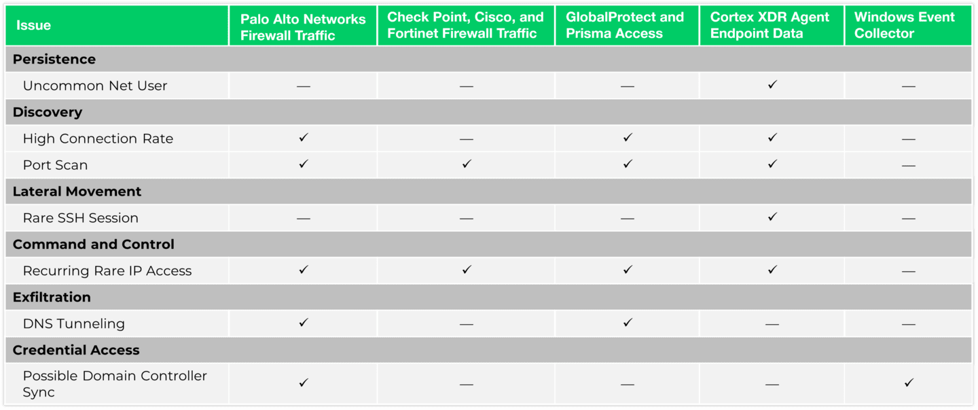

Building Blocks of the Analytics Engine: Analytics Detectors
The Analytics Engine organizes its behavioral analytics activities by units called detectors. Each detector is specialized for specific attack types and generates one type of analytics issue when anomalies and suspicious behaviors are detected.
To raise issues, each detector creates its own baseline by processing more than 1,000 data dimensions. The consumed data, in terms of logs and issues, and the time needed for training and testing periods vary by detector type. The data sources include Cortex XDR agents, Palo Alto Networks Next-Generation Firewalls, GlobalProtect and Prisma Access, and external syslog sources such as Check Point firewalls.
Detectors constantly update their baselines to align with dynamically changing network topology and usage.


Enabling Cortex Analytics
You can enable the Cortex Analytics Engine in Settings > Configurations > Cortex – Analytics.
The following are important data collection requirements when enabling the Analytics Engine:
- 
- Data Storage Minimum
- The data collected from at least 30 endpoints over a minimum of two weeks must be available in the storage.
- 
- Collection Period
- For cloud audit logs, the engine requires a minimum of five days of collection. The Enable button will be grayed out (disabled) until the data requirement is met.
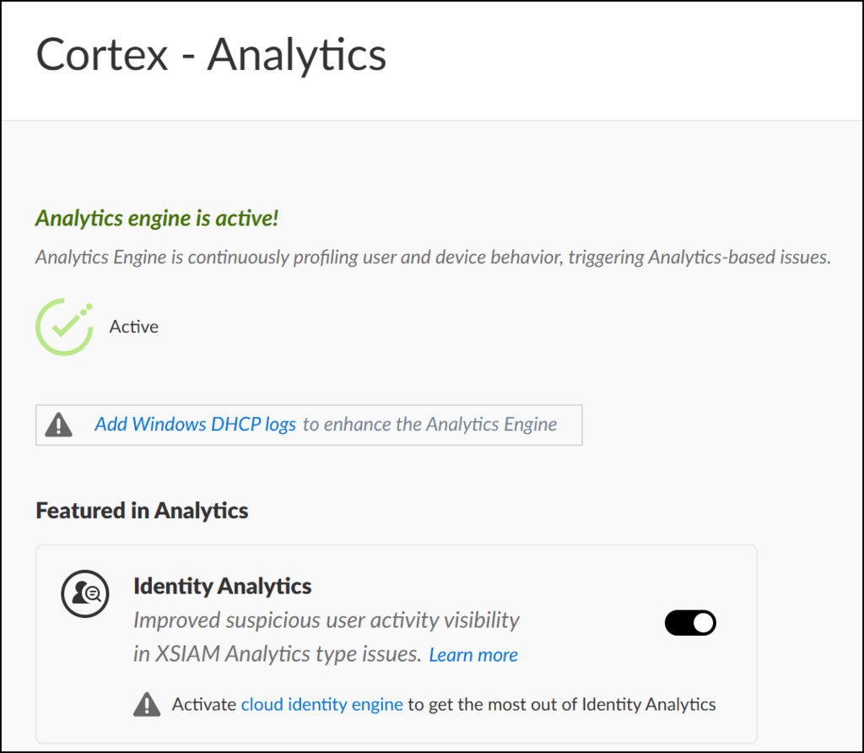

Course Summary
Now that you've completed this course, you should be able to:

- Describe the security-related data types sent to Cortex
- Describe how Cortex stitches the logs and issues
- Describe how the Analytics Engine models the data using machine learning (ML)
- Describe MITRE ATT&CK tactics and how the Analytics Engine provides full coverage
- Explain Analytics Engine detectors

